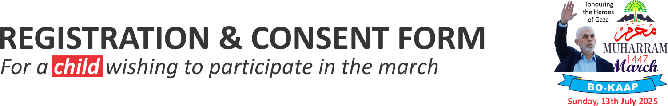
1 | DETAILS OF PARENT/GUARDIAN
1.1 | Name and surname of parent/guardian
1.2 | Address
1.3 | Telephone number(s)
2 | DETAILS OF CHILD
2.1 | Name and surname of child
2.2 | Age of child
2.3 | Name of current/last madrassa
2.4 | Name of primary/high school
3 | CONSENT AND INDEMNITY
2.1 | By submitting this registration form electronically via WhatsApp, I, the parent/guardian of the abovementioned child, hereby consents to my child’s participation in the Muharram March and indemnifies my school, madrassa and the organisers of the event against any claim which may arise from any incident that may occur at this event. | Signature of parent/guardian if a printed copy of the form is handed in
4 | PAYMENT OF REGISTRATION FEE
4.1 | Payment for my child | R50-00
4.1 | Would you like to sponsor the fee for a needy child (R50) | Yes/No
4.2 | Total payment | R
4.3 | Method of payment (cash, card or EFT)  Boorhaanol Social Welfare, FNB Long Street  A/c No.6222 8966 464
4.4 | Date submitted

Please note : This event is subject to suitable weather conditions on the day.

